STUDENT LESSON

AB31 – Stacks and Queues
Student LESSON

AB31 – Stacks and Queues

INTRODUCTION: Earlier in Lesson A9, Recursion, the concept of a stack was introduced. A stack is a linear data structure with well-defined insertion and deletion routines. Data is both placed and taken from the ‘top’ of the stack. Queues are very similar to stacks, except that Queues remove data from the front while adding data at the end.

The key topics for this lesson are:

A. Stacks
B. The Java Stack Class
C. Queues
D. The Java Queue Interface

VOCABULARY: add POP
PUSH QUEUE
remove STACK
TOP

DISCUSSION: A. Stacks

1. A stack is a linear data structure.

2. All additions to and deletions from a stack occur at the top of the stack. The last item pushed onto the stack will be the first item removed. A stack is sometimes referred to as a LIFO ('Last-In, First-Out') structure.

3. Two of the more important stack operations involve pushing data onto a stack and popping data off the stack.

4. Diagram 31-1 (below) illustrates the push operation:

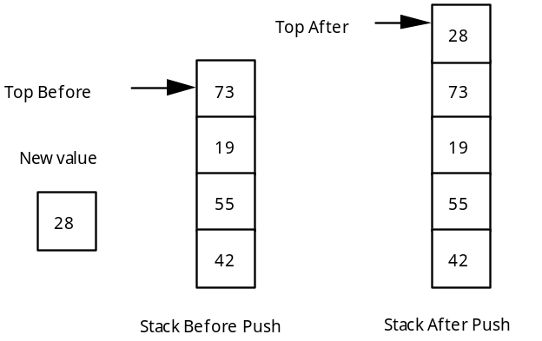

Diagram 31-1: Push Operation

5. Diagram 31-2 illustrates the pop operation:

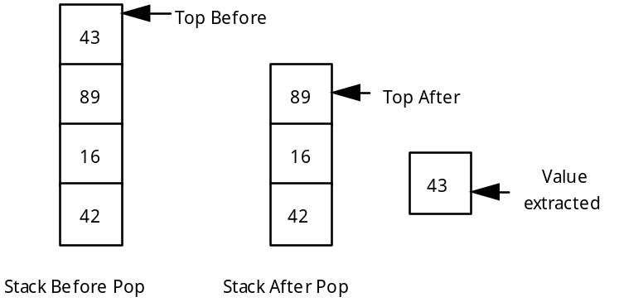

Diagram 31-2: Pop Operation

B. The Java Stack Class

- The AP subset requires students to know the following methods of the java.util.Stack:

boolean
      - empty()
//Returns true if the Stack has no elements.
E peek()
//Returns the top element without removing it.
E pop()
//Returns and removes the top element.
E push(E item)
//Adds item to the top of the Stack.

- To declare a reference variable for a Stack, do the following.

Stack <ClassName> myStack =
new Stack <ClassName> ();

- Here is a short example showing how to create, populate, and deconstruct a Stack:

Stack <Integer> s = new Stack <Integer> ();

for(int i = 1; i <= 5; i++){
s.push(i);
}

for(Integer temp : s){
System.out.println(temp);
}

while(!s.empty()){
System.out.println(s.pop());
}

Output:

1
2
3
4
5
5
4
3
2
1

Notice that the output first prints up to five and then comes back down again. The for each loop is only treating the Stack like a List, so it is not popping any of the data off the Stack. Therefore, during the while loop, the Stack is not empty and can still be used. Also, the for each loop will start at the beginning of the List and go to the end. Because Stacks deal with all the data transactions at the top (end) of the Stack, the for each will go in the opposite order that the pop method will.

C. Queues

1. A queue is a linear data structure that is similar to waiting in line. A queue has both a front and an end.

2. Data must always enter the queue at the end and leave from the front of the line. This type of action can be summarized as FIFO ('First-In, First-Out').

3. A queue is the appropriate data structure when simulating waiting in line. A printer that is part of a multi-user network usually processes print commands on a FIFO basis. A queue would be used to maintain the order of the print jobs.

D. The Java Queue Interface

1. The AP subset requires students to know the following methods of the java.util.Queue interface:

void add(E item)

//Adds item to the end of the Queue.
boolean
      - isEmpty()
//Returns true if the Queue has no elements.
E peek()
//Returns the top element without removing it.
E remove()
//Returns and removes the first element.

      - To declare a reference variable for a Queue, do the following:

Queue <ClassName> myQ =
new LinkedList <ClassName> ();

      - This is an easy way to create a new Queue object without having to create a whole new class to implement the Queue interface. There are other ways to implement a Queue but this is the only way that AP requires.

      - Here is a short example showing how to create, populate, and deconstruct a Queue.

Queue <Integer> q = new LinkedList <Integer> ();

for(int i = 1; i <= 5; i++){
q.add(i);
}

for(Integer temp : q){
System.out.println(temp);
}

while(!q.isEmpty()){
System.out.println(q.remove());
}

Output:

1
2
3
4
5
1
2
3
4
5

In this example, both loops print the exact same thing. This is because a Queue adds data to the end and takes data from the front, so it is going from the front to the end when removing data, just like the for each loop.

first
last
null
null
Object A
Object B
Object C

first
last
null
Object A
Object B

SUMMARY/ REVIEW: | The stack is what makes recursive algorithms possible. In Lab Assignment AB31.1, Inorder, a better understanding of the recursive inorder function used to traverse a binary tree will be gained.

ASSIGNMENT: Lab Assignment AB31.1, Inorder
Lab Assignment AB31.1, Data File, file20.txt
Lab Assignment AB31.2, PrintByLevel
Lab Assignment AB31.2, Data File, fileA.txt, fileB.txt,
Lab Assignment AB31.3, RPN

